LOAN STATUS PREDICTION USING EXPLORATORY DATA ANALYSIS

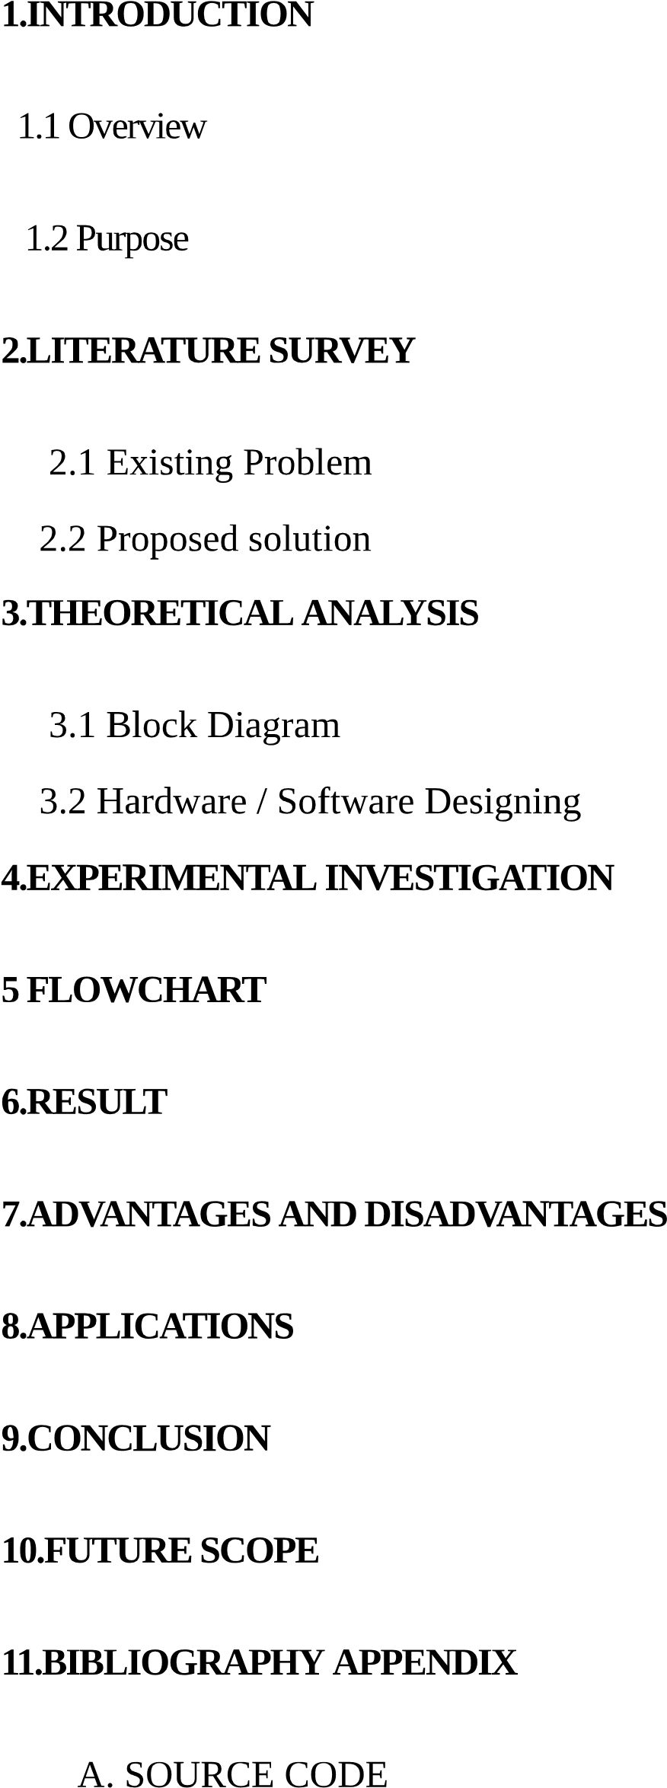

1.INTRODUCTION:

1.1 Overview:

* With the help of machine learning and Linear regression algorithm ,this application is build to choose the perfect candidate who eligible to acquire the loan.
* With the help of this application we can predict the loan status and if the candidate would be able to pay the loan in the time.
* To predict the out come I have used Data set consisting some real time values of accounts holders who are paying loans.

1.2 Purpose:

* Purpose of this application is to predict whether the client is eligible to acquire the loan or not and also to predict whether he or she would pay the loan in time or it would be Charged off.

2.LITERATURE SURVEY:

* Classification is the most commonly applied data mining technique, which employs a set of pre-classified examples to develop a model that can classify the population of records at large. Fraud detection and credit risk applications are particularly well suited to classification technique. This approach frequently employs Decision tree based classification Algorithm. In classification, a training set is used to build the model as the classifier which can classify the data items into its appropriate classes. A test set is used to validate the model.

3.THEORETICAL ANALYSIS:

* Block diagram

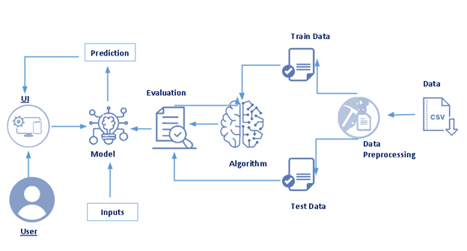

* Hardware and Software designing:

Anaconda Navigator : Anaconda Navigator is a desktop graphical user interface (GUI) included in Anaconda distribution that allows you to launch applications and easily manage conda packages, environments, and channels without using command-line commands. Navigator can search for packages in a local Anaconda Repository. It is available for Windows, macOS, and Linux.

Flask : Flask is a micro web framework written in Python which is used to build web applications.

4.Experimental Investigation:

* Investigated the previous systems to get some information about the project and searched about the flask web platform.

5.Flow Chart:

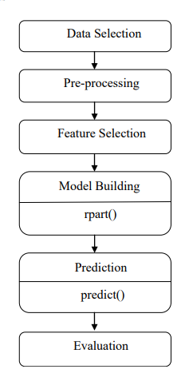

6.Result:

* Entering the required credentials to predict the outcome.
* Step by step fill the details.

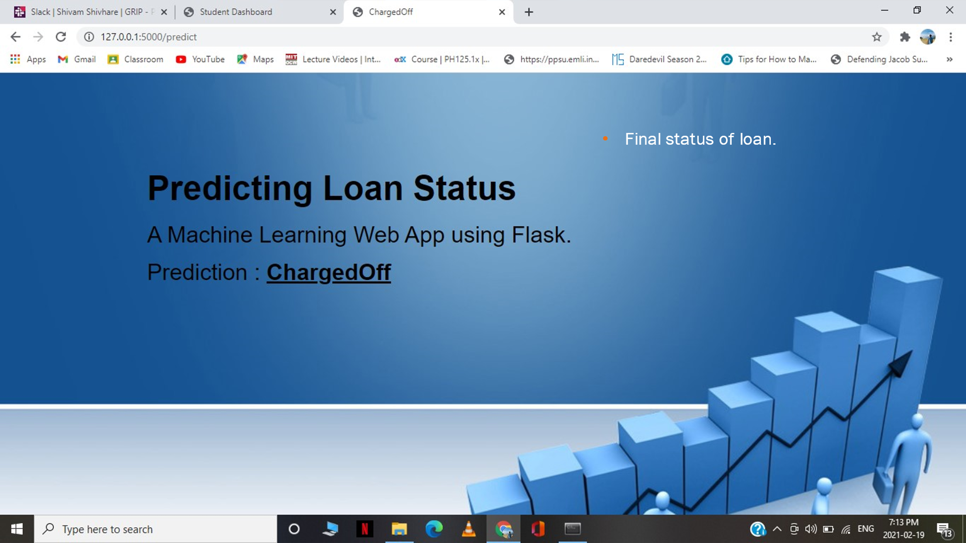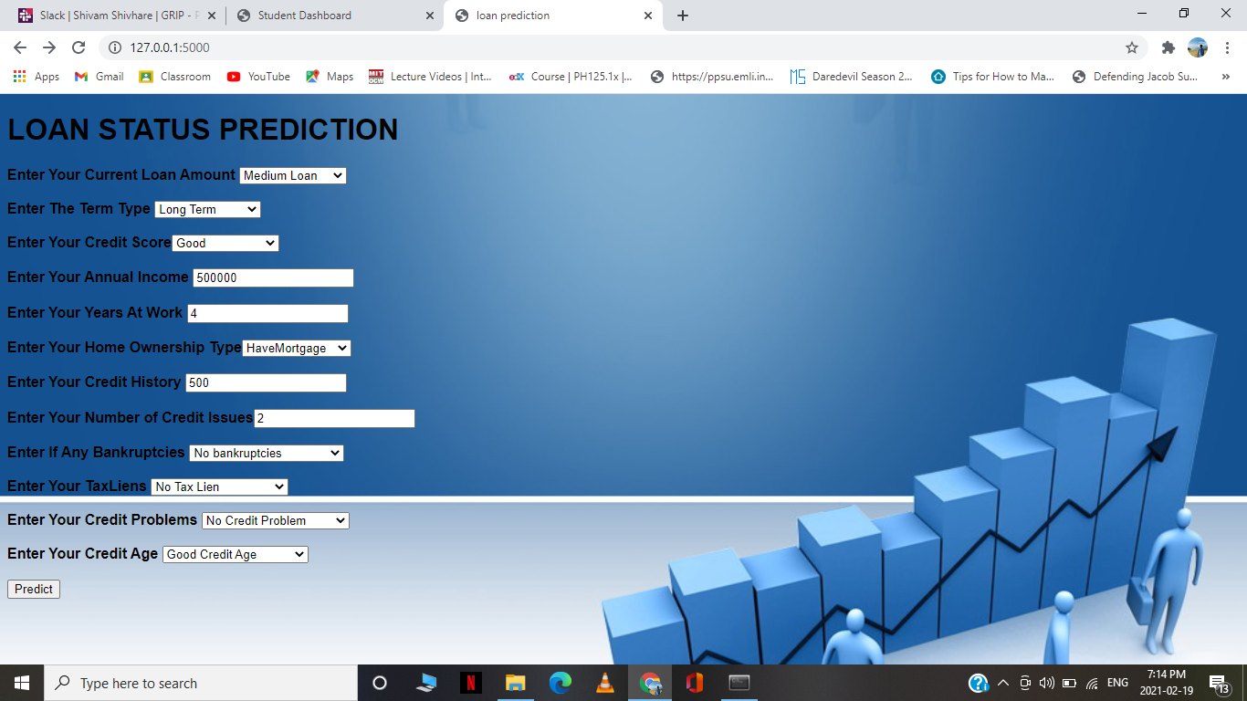

* After entering the details you can see the out put in the form of chargedOff loan or Fully paid loan.

7.Advantages and Disadvantages:

* Advantages:
* One of the main advantage is that the prediction is going to be done by the help oh machine learning and that will give you the most accurate outcome. It also reduces the man force for performing experiments to find the solutions to the problems.
* It is also budget friendly as it is less expensive.
* Disadvantages:
* There is possibility that the outcome will not be predicted in the right way and it would not be exactly approximate and that could be troublesome.

8.APPLICATION:

* It can be used in bank and to predict the status and the approval of the loans.
* It will consider everything and after that they will give the most possible accurate outcome which favours the bank.

9.CONCLUSION:

* In this study, a model of prediction is use with the use of algorithms of logistic regressions. More than 600 sample data were collected to use and the tested to build the model of logistic classifier to predict the status of the loan.
* The maximum accuracy this model can achieve is more than 90%.
* And this accuracy is achieved with the help of the model of regression.

10.Future Scope:

* This model can be used to predict the outcome and it is compatible with many different inputs within fraction of seconds. This model will save a lot of time for the bank sectors and their employees.

11.BIBLIOGRAPHY:

* Michael Bowles. Machine Learning in Python: Essential Techniques for Predictive Analysis.